CREATIVE VISIONARY – SPACEAI

Introduction
SpaceAI is a fictional startup focused on Artificial Intelligence and Space Technology.
The objective of this project is to create a complete and consistent visual brand identity using AI image generation tools.

Objective
To design a full brand identity including:
- Logo
- Hero Image
- Icon Set
- Consistent AI-generated character scenes
This demonstrates prompt engineering and AI-driven visual creation.

Tools Used
- ChatGPT/GEMINI Image Generation
- AI Prompt Engineering
- Generative AI Models

Generated Brand Assets
1. Logo
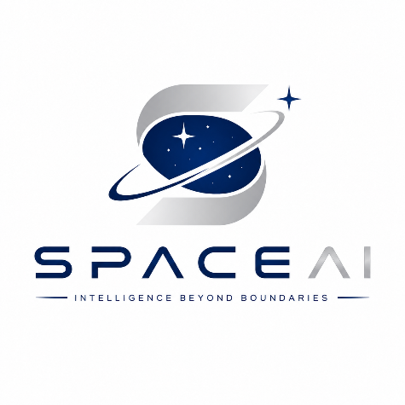
2. Hero Image
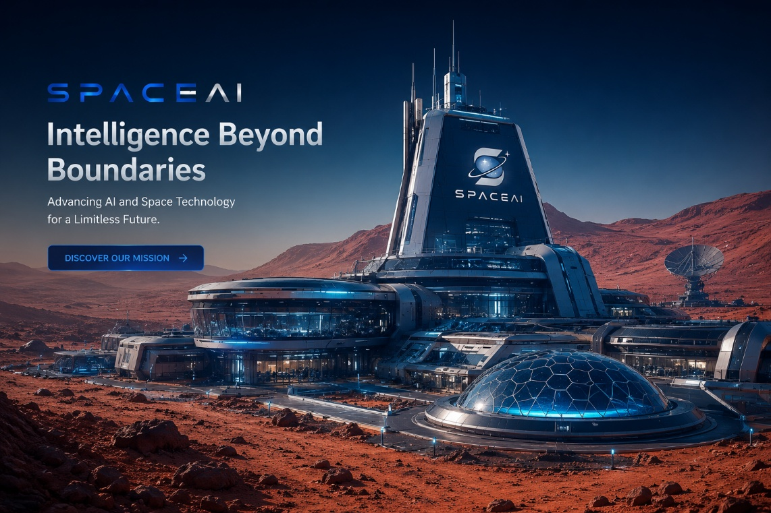
3. Icon Set
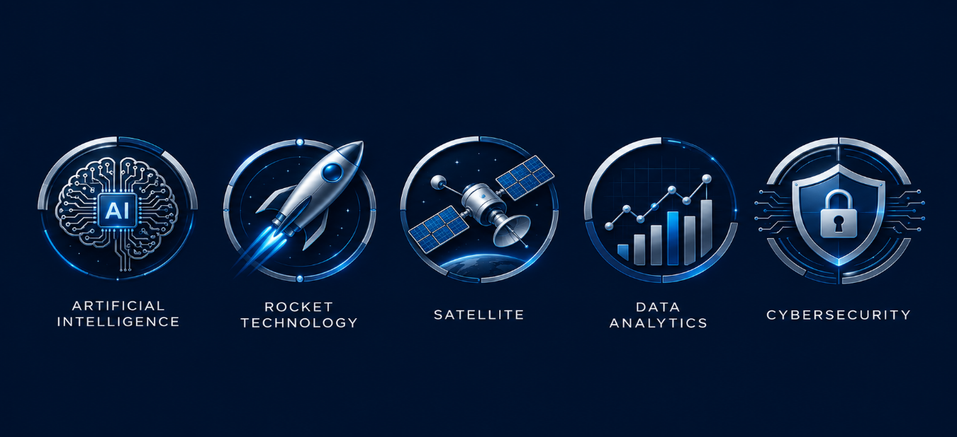

Brand Consistency Demonstration:
The same SpaceAI humanoid AI assistant was maintained across multiple environments to ensure visual consistency and brand identity.

Scene 1
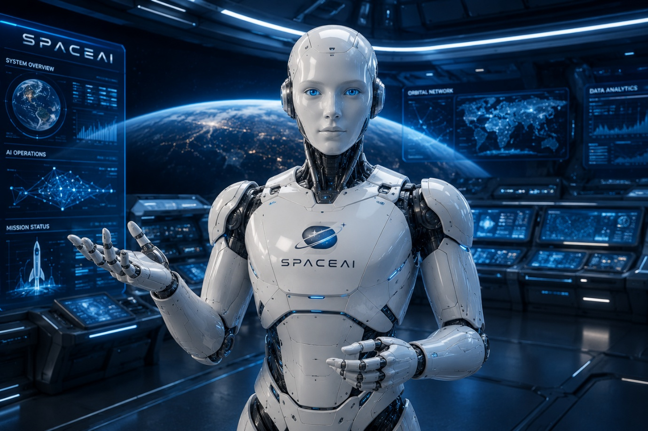
Scene 2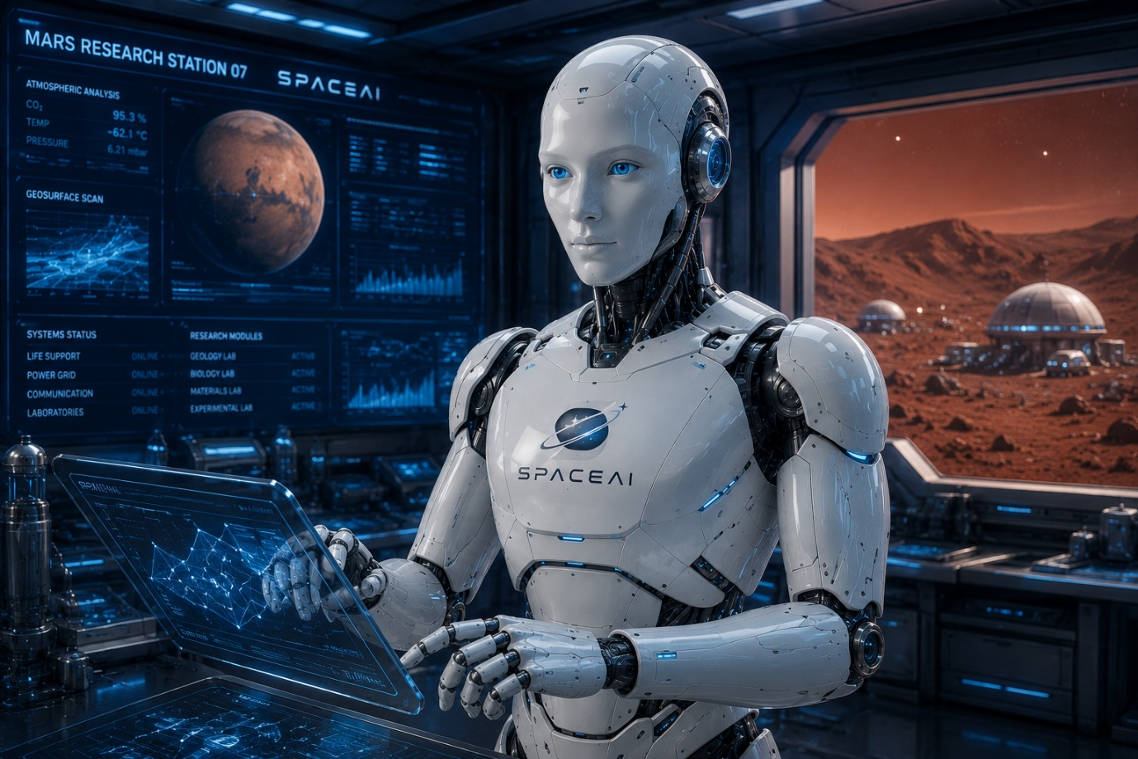
Scene 3
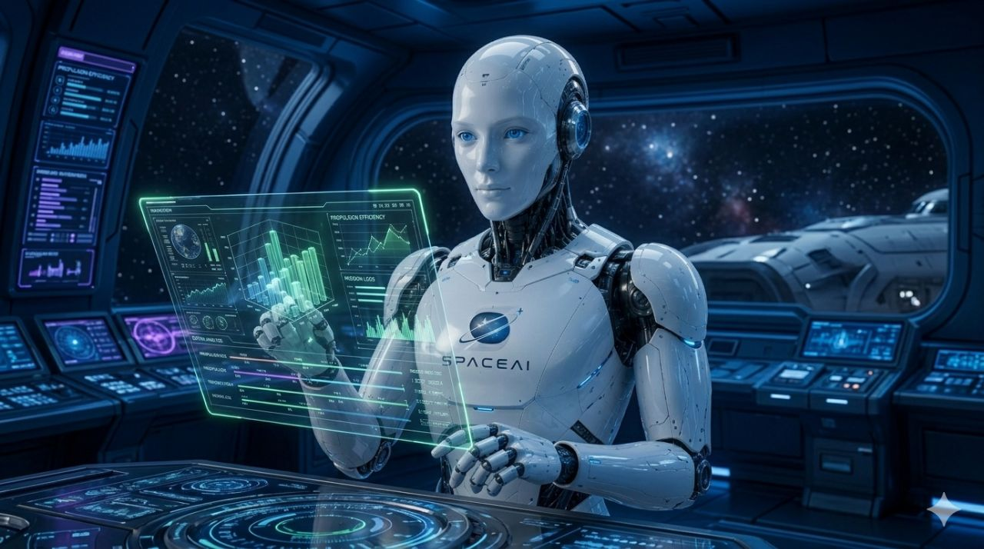

Conclusion
This project successfully generated a complete visual identity for SpaceAI using AI image generation.
The results demonstrate strong brand consistency, effective prompt engineering, and the ability of AI tools to create professional-level visual assets.

